This question concerns the following symbol, which describes a directional control valve:
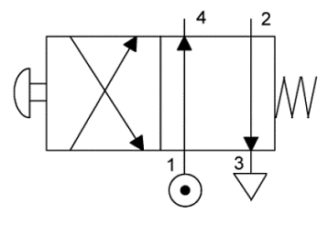
Decide whether each of these statements is TRUE (T) or FALSE (F).
With the push-button not pressed:
(i) Pressure is applied to port 4.
(ii) Port 2 is vented.
Which option BEST describes the two statements?
(i) T (ii) T
(i) T (ii) F
(i) F (ii) T
(i) F (ii) F

This question concerns the following symbol, which describes a directional control valve:

Decide whether each of these statements is TRUE (T) or FALSE (F).
When the push-button is pressed:
(i) Pressure is applied to port 4.
(ii) Port 2 is vented.
Which option BEST describes the two statements?
(i) T (ii) T
(i) T (ii) F
(i) F (ii) T
(i) F (ii) F

This question concerns the following symbol, which describes a directional control valve:

Decide whether each of these statements is TRUE (T) or FALSE (F).
After pressing and releasing the push-button, then:
(i) Pressure is applied to port 2.
(ii) Port 4 is vented.
Which option BEST describes the two statements?
(i) T (ii) T
(i) T (ii) F
(i) F (ii) T
(i) F (ii) F

